

**Engineering Exploration Project Report on**

**RAILWAY TRACKING SYSTEM**

**DURGAM DEEKSHITA 160121771077**

**GUDURU GEETIKA 160121771078**

**JAMALPUR NAVYA SREE 160121771079**

**PASUNURI KATHYAYINI 160121771088**

Under the mentorship of **Dr.RAJANIKANTH ALUVALA**, Associate Professor

Core branch: **ARTIFICIAL INTELLIGENCE AND DATA SCIENCE (I-2)**

**Submitted to**

**Department of Mechanical Engineering**

**Chaitanya Bharathi Institute of Technology (A)**

**August, 2022**

**LIST OF ­­­­­­­­­­­­­­­CONTENTS**

Abstract 3

Background 4

Motivation 5

Problem Statement 6

Formulation 7

Results & Discussion 17

Summary 19

Future scope 20

References 21

# ABSTRACT

Development of population of a country is directly related to it’s transportation facility. In India, transportation facility is majorly handled by “The Indian Railways”. In this report, we proposed a method for “Real-time Tracking of a Train and its arrival and departure timings”. In our proposed method, API key of an API documentation is used to access the data of a particular train. The data we use here is dummy and just for the presentation purpose. This data is further used to develop a website that lets the user (here, passenger) to find the details of the train he/she is looking for. The objective of this manuscript is to provide information about the timings of the train to the passengers in need, which helps in reducing the search time, avoiding missing trains and track down delay problems easily at your fingertips.

**BACKGROUND**

Many passengers choose Railways for their travel. The Indian Railways is a huge network. At times, these passengers have a hard time knowing the details of the train ,mainly, it’s timings. Sometimes a train gets delayed and the passenger waits for the train in a state of confusion without knowing if it has already left the station or yet to arrive. As a solution, we developed a website to help these passengers by informing them about the train details and time delays if any. This way if a passenger has any doubts regarding the timings of the train i.e. arrival and departure and any delay ,they can use our website and get a clear idea about the train timings and have a hassle-free journey experience.

**MOTIVATION**

India has the fourth largest railway network with over 22,593 operating trains and a daily

passenger count of 24 million passengers. So, The Indian Railways is a service used by many people. In order to provide information about the train to the passengers easily, we developed a “Railway Tracking System” that eases the work of a regular Indian Railway passenger. Our project allows the users to get the information of a particular train. Every train has a unique code which can be used to track the train on a particular day. This way we can know the details of the train i.e arrival and departure timings at respective stations, and also the time of delay for the train to reach the station if there is any delay. Through this system, we aim to ease down the work of the passenger and not let their time get wasted in worrying, waiting or searching for the details of the train.

**PROBLEM STATEMENT**

Rail transportation is a convenient mode of travel and safe in many countries. However, Rail transportation in some countries has significant long delays. In such situations, the passengers are in a state of confusion whether to wait for the train or to search for another alternative. Arrival time prediction and rescheduling the time table are partial solutions to tackle the delay problem. At times like this, information can be provided by our website to the passenger who wants to know about the current situation of the train and the arrival and departure timings as well.

**FORMULATION**

To develop the website proposed by us in the report, we need to get the access to the required data first. To acquire data, we can make use of several API documentations that are provided by different websites on the internet, both paid and free. We used one such website to access the data.

Here is an example of a website that provides data for us in API documentations:

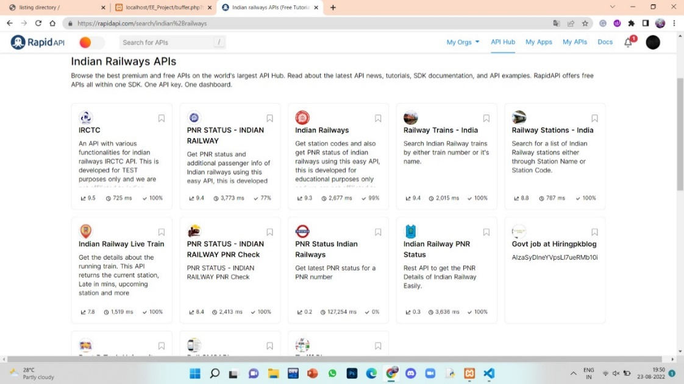

**Fig.1 API key providing website- Rapidapi**

When we select the API that satisfies our requirements, we open it by registering on the site and get an API key that will let us access the information.

As you click on the API, you get a page that contains an executable code with URL and the API key, that is shown below:

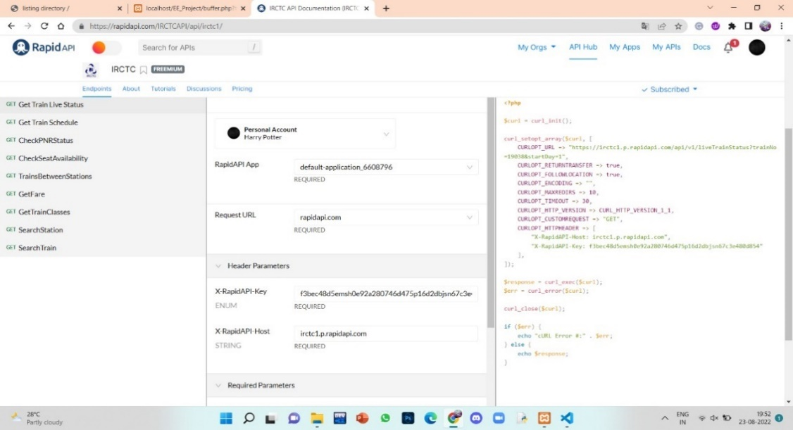

**Fig.2 API documentation of Indian Railways**

We execute the above given code and get access to data, the execution is done in Visual Studio Code and the output is displayed in our chrome page as we enter the file path of the code

The below picture contains the executable code written as .php file:

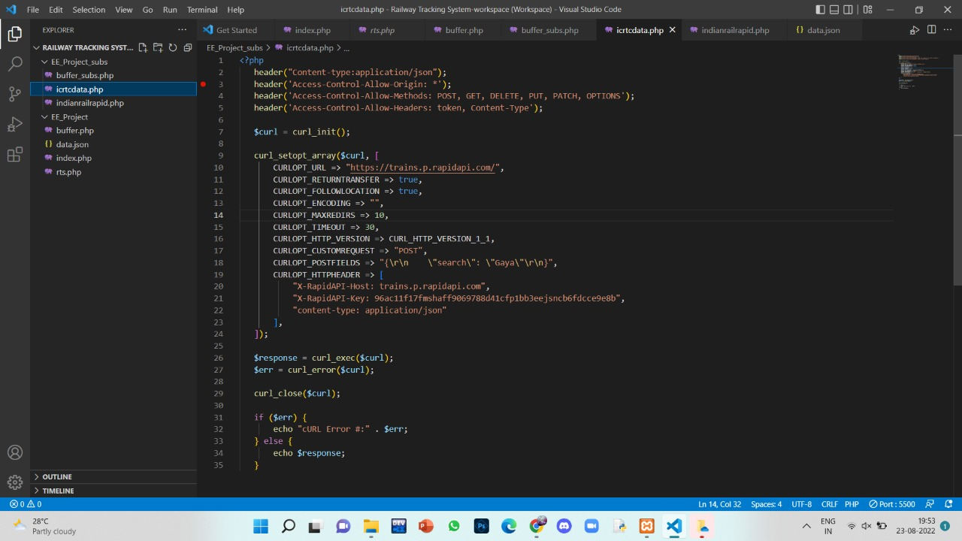

**Fig.3 Executable code written in .php file**

The below picture shows the output generated after it's execution, which contains the data we require

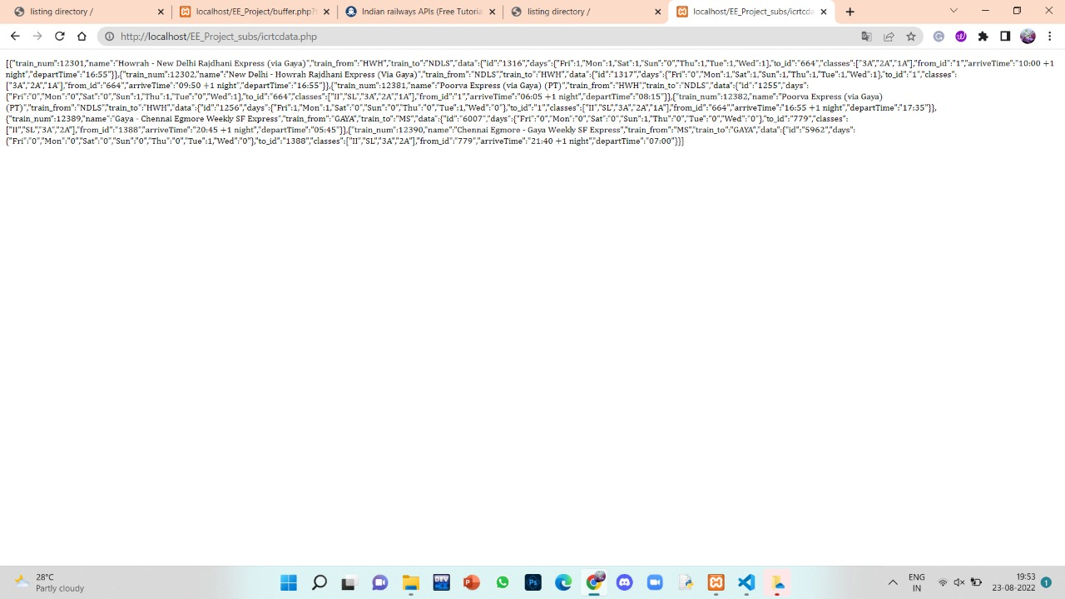

**Fig.4 Output generated in JSON format**

The generated output is in JSON(JavaScript Object Notation) format which contains data in attribute-value pairs and arrays. It is stored in JSON format to make the text more easily readable and understandable.

To make this text more readable, we format it using a website, “jsonviewer,stack.hu”

As we copy and paste the file in the website, it formats the output in the following manner as shown in the figure.

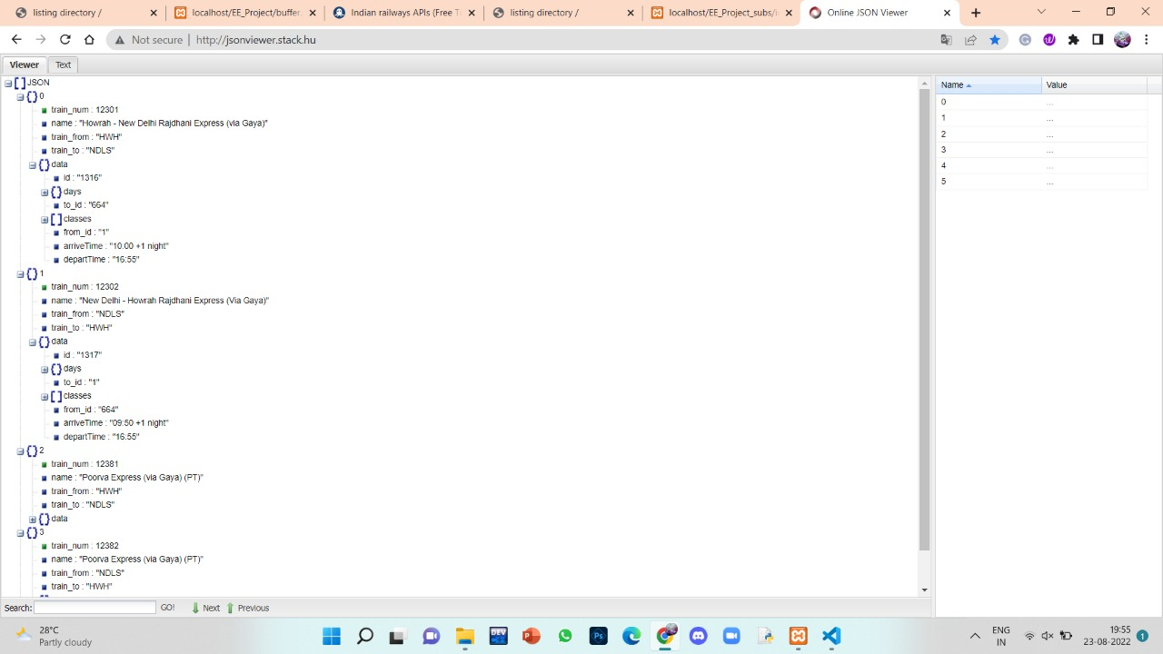

**Fig.5 Formatted “.json file” obtained in json viewer**

As mentioned earlier, there are several such API documenations available that has different sets of data, here are a few example outputs which are obtained from different websites and APIs that contains several other details of the trains.

**EX.1:**

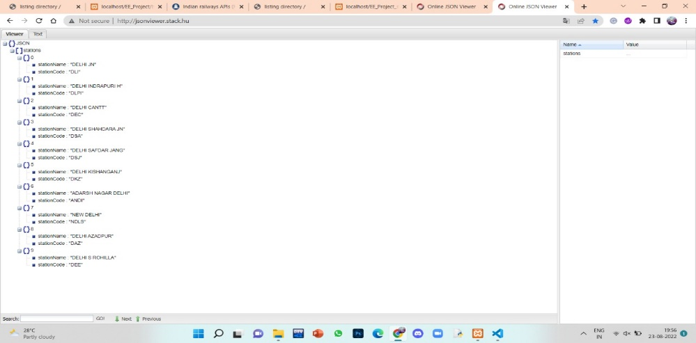

**Fig.6 Example formatted json file of an API documentation**

**EX 2(The one which is used to develop this project):**

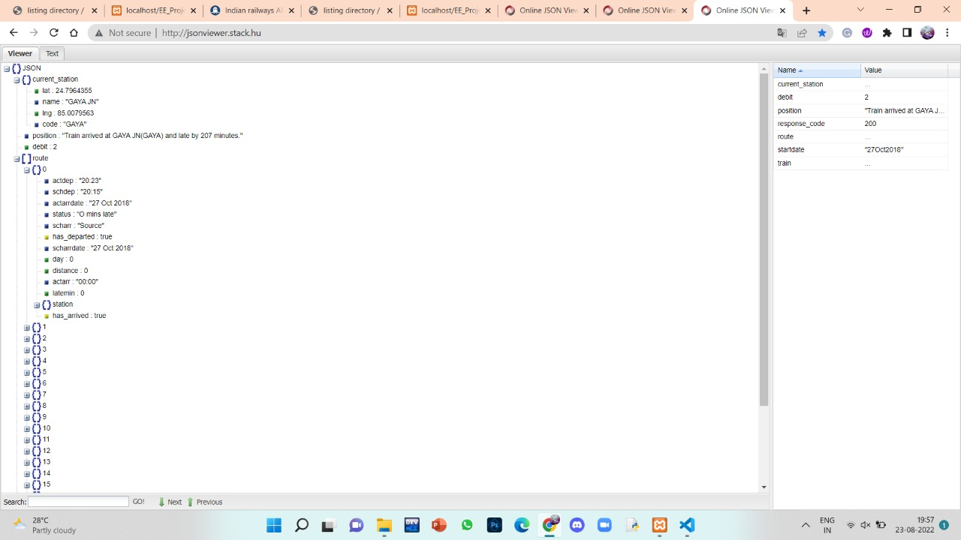

**Fig.7 Formatted json file obtained from API used in our project**

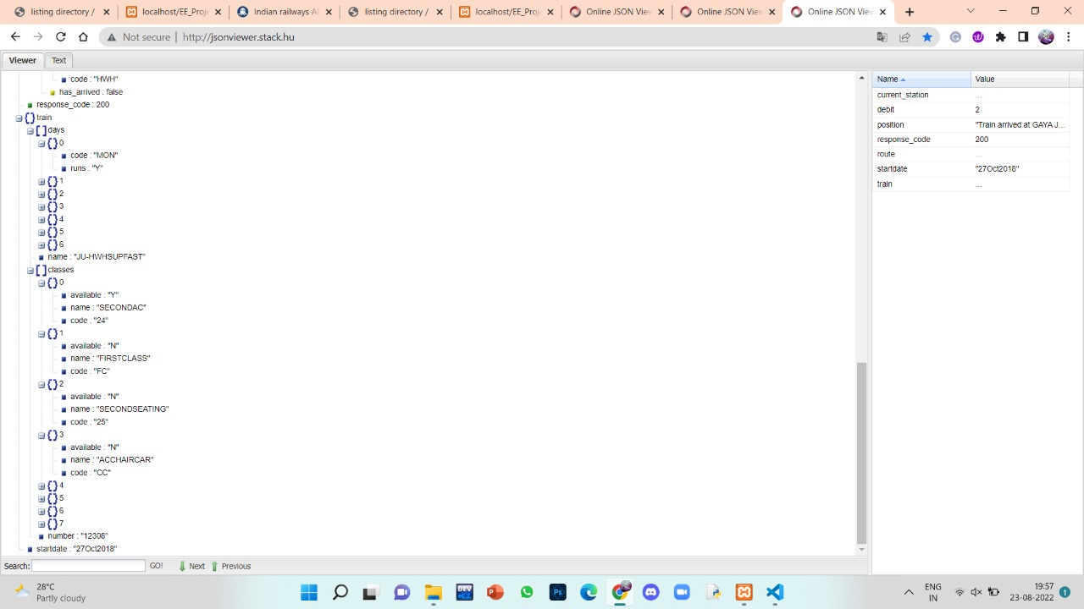

**Fig.8 Continuation of the Fig.7**

The above shown data, as you can see, contains the details of a train that goes from Jodhpur to Howrah covering a total of 22 number of stations. It shows the current location of the train, including it’s station name, latitude and longitude.In addition to them, it also contains the actual and scheduled arrival and departure timings of the train in respective stations, the delay in time of arrival and departure, the day of it’s journey, distance covered and the status of arrival and departure.

It also contains the data of available seats in different coaches of the train, at the end.

Now, we use this data to implement our project.

First, we create a folder named “EE Project”, that has some files in it, namely, “index.php”, “buffer.php”, “data.json” and some pictures we sued to design the website.

The first page of the website will let the user give the inputs of the required train that he wants to track the details of, the inputs are 1) the code of the train and 2) the start date.

The code for this required thing is written in the “**index.php”** file.

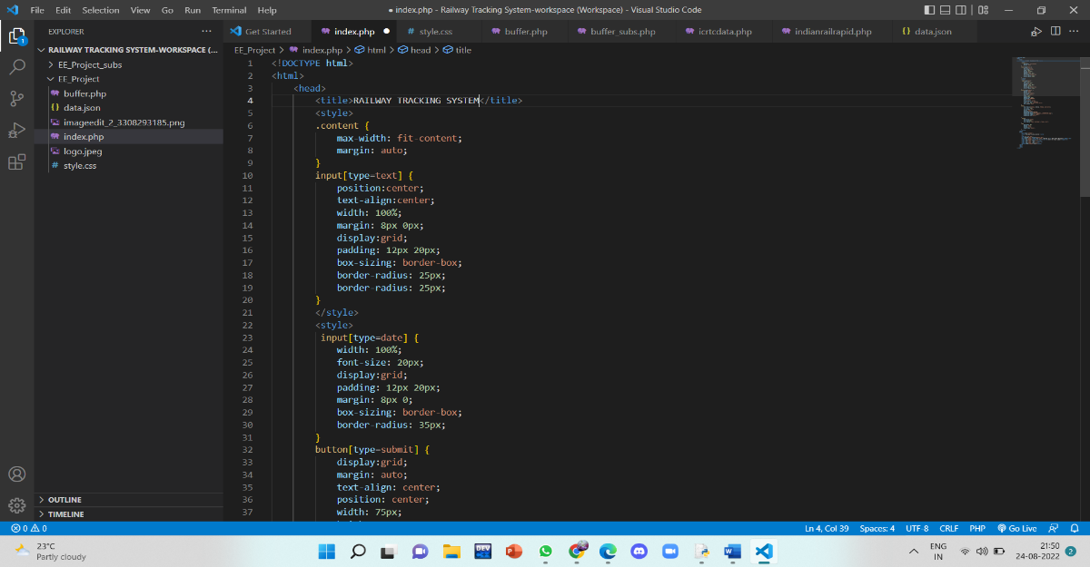

**Fig.9 Code of “index.php” file written in VSCode**

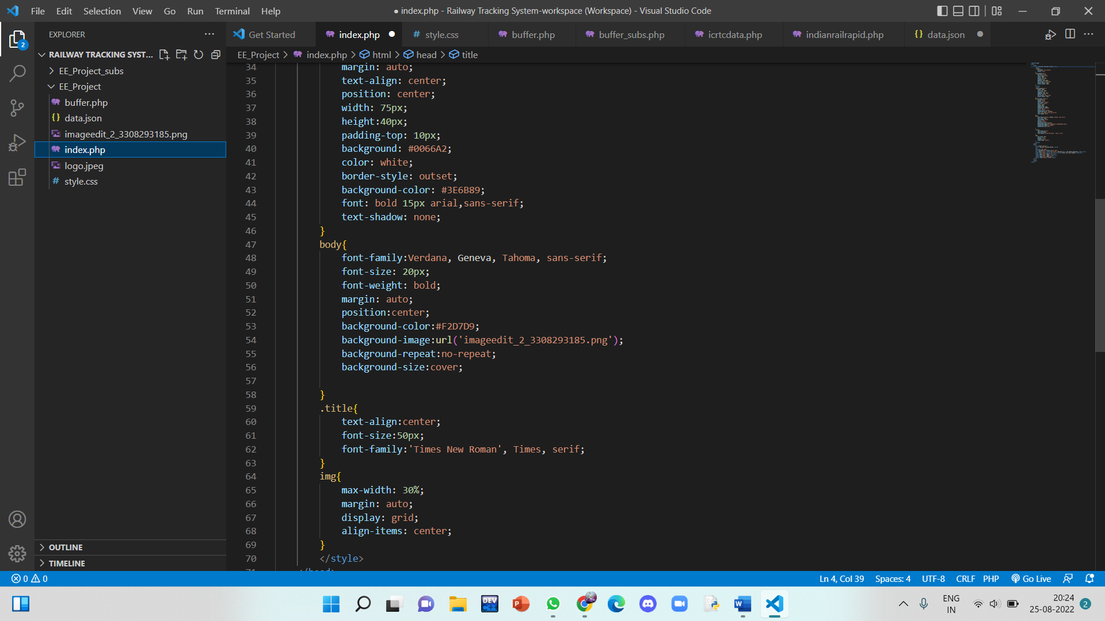

**Fig.10 Continuation of the code in “index.php”**

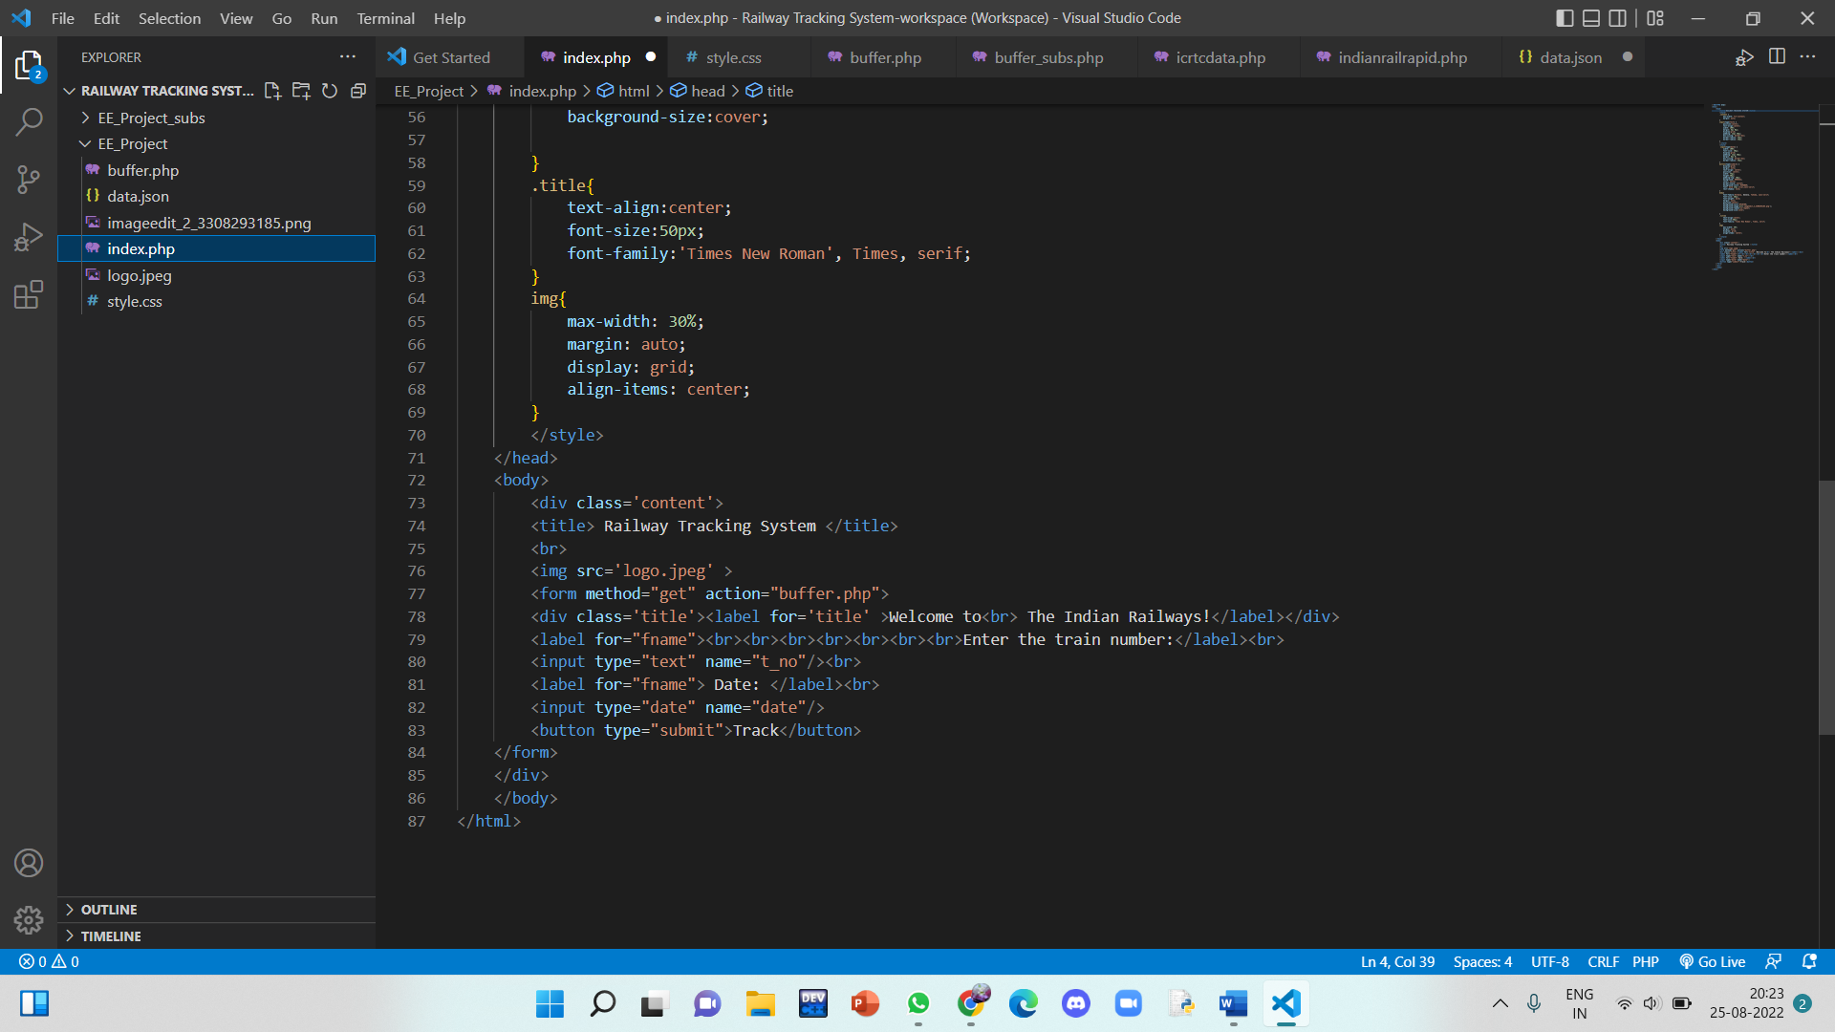

**Fig.11 Continuation of the code in “index.php”**

This code gets the action i.e., after the entry of required inputs, it redirects you to the next page which contains the details of the train, from another file named, **“buffer.php”.**

The file “buffer.php” gets access to data from the “data.json” file which is stored in the same folder.

This “data.json” file contains the details of the train in JSON format.

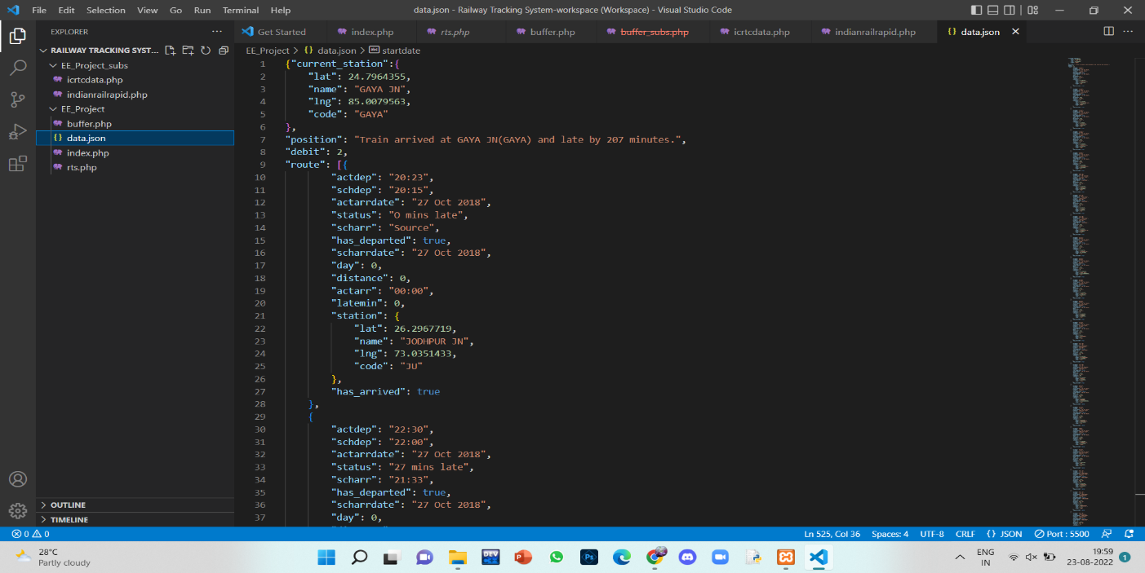

**Fig.12 Output generated from API which is stored in “data.json” file**

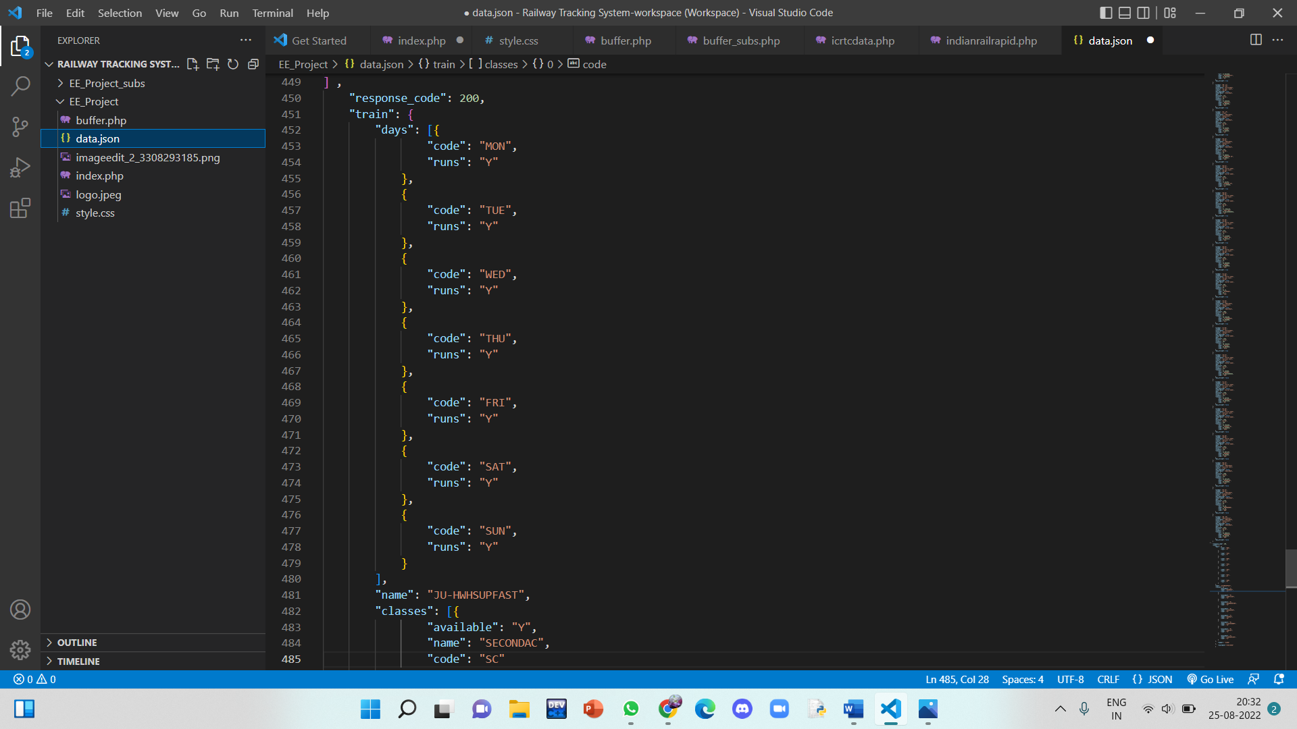

**Fig.13 “data.json” file**

**Only some part of the data is shown as it has nearly 500 lines.

Now, the buffer.php takes the inputs from “index.php” and processes the data from “data.json” file and gives us the output in a tabular form that contains the required details of the train.

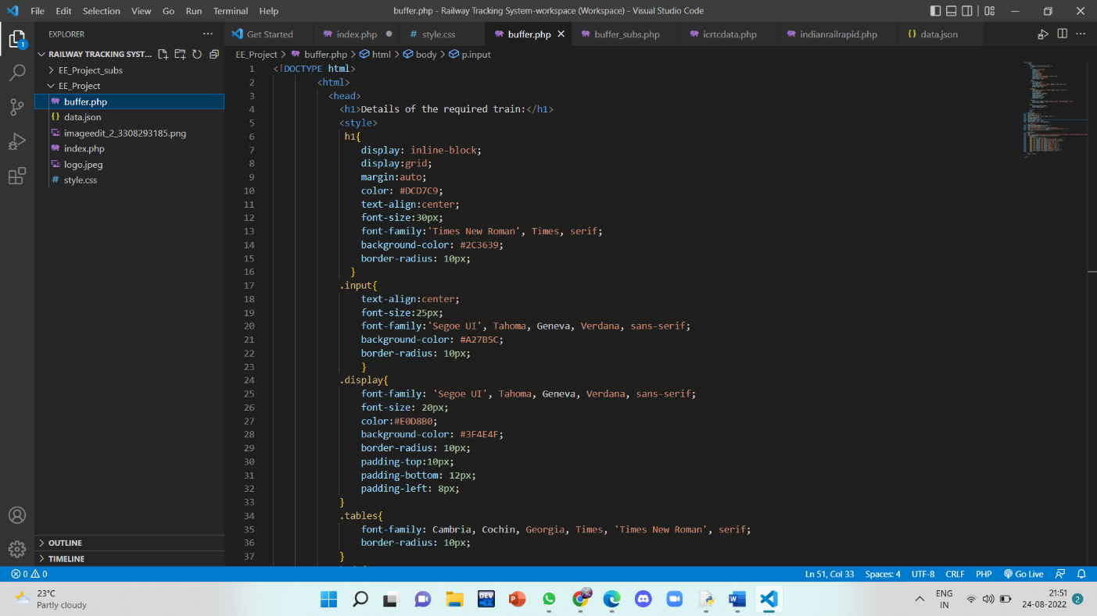

**Fig.14 Code of “buffer.php” file written in VSCode**

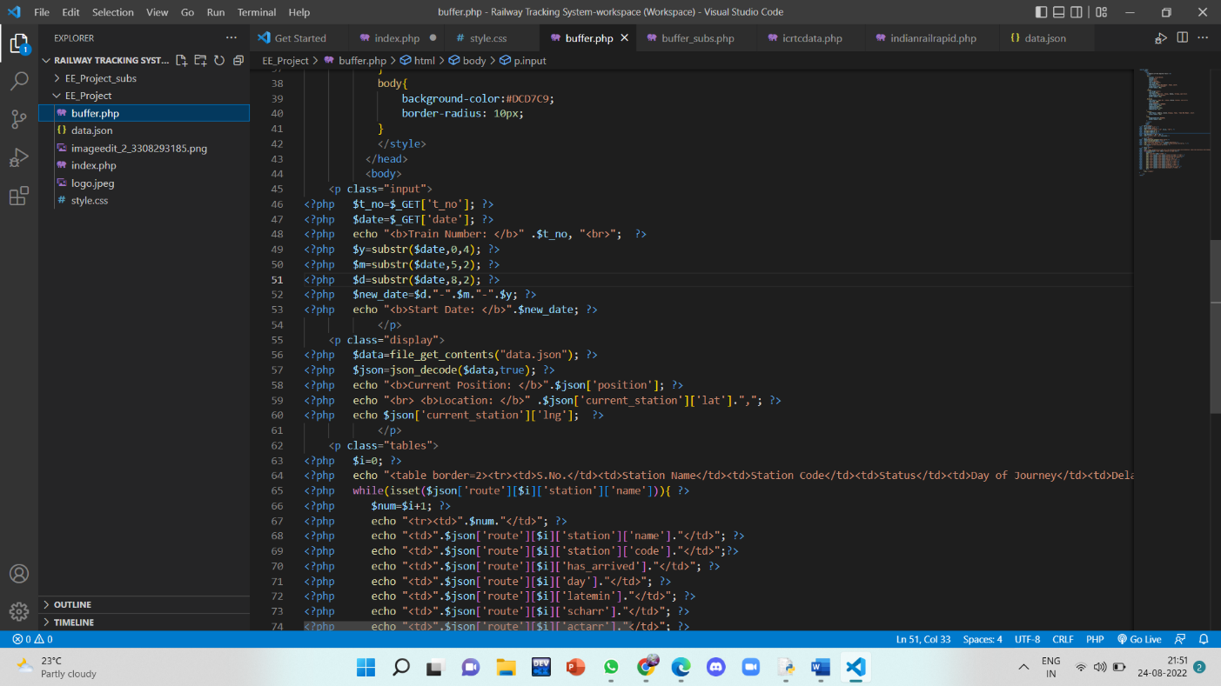

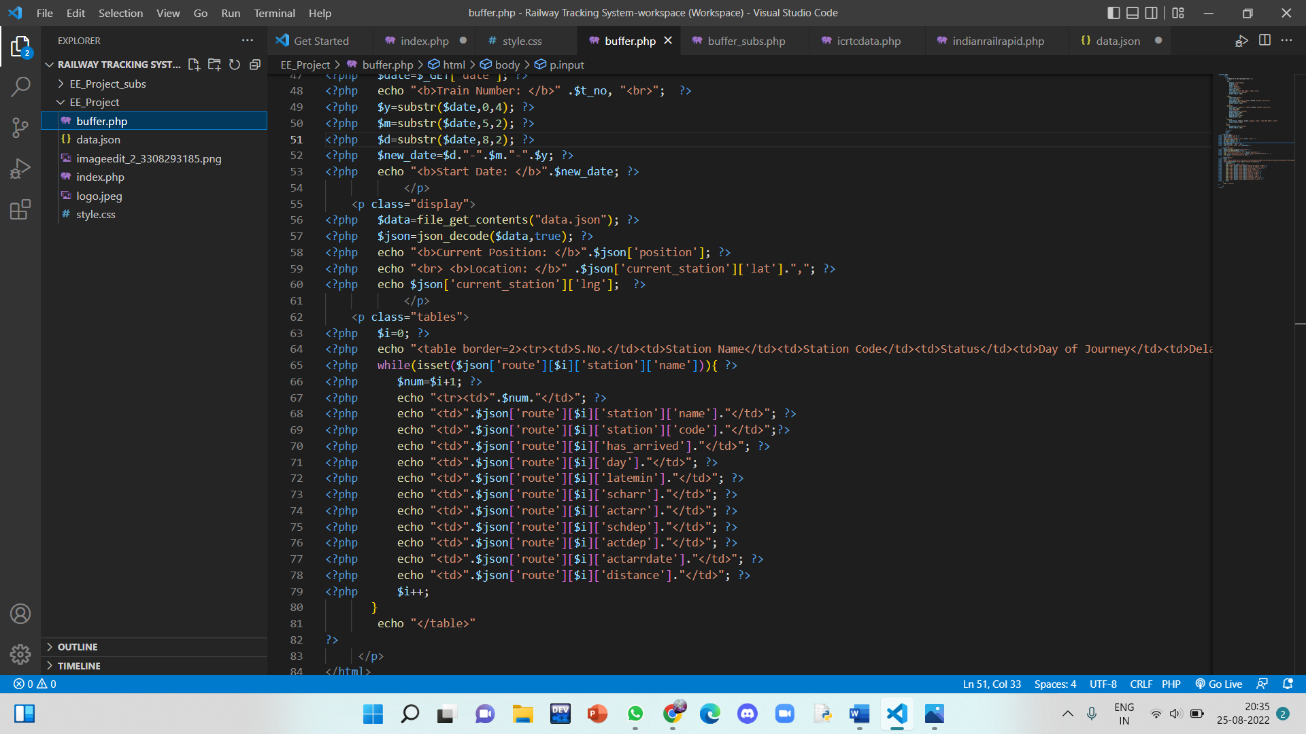

**Fig.15 &16 Continuation of “buffer.php” code**

The styling of the website is done using **“HTML and CSS”**, that are included directly in the php file without any change in the original syntaxes.

The writing of code is finished now and the implementation should be done.

To implement the code, we need to install an application called **“XAMPP”**, that lets the php files run on our browser. We transfer the folder in which we created all these files, i.e., EE_Project into an other folder named **“htdocs”** which is present in the **“xampp”** installation folder. This will enable the code to execute smoothly.

We open the **“Xampp Control Panel”** application and click on the “start” button of **“APACHE”** (which is a server).

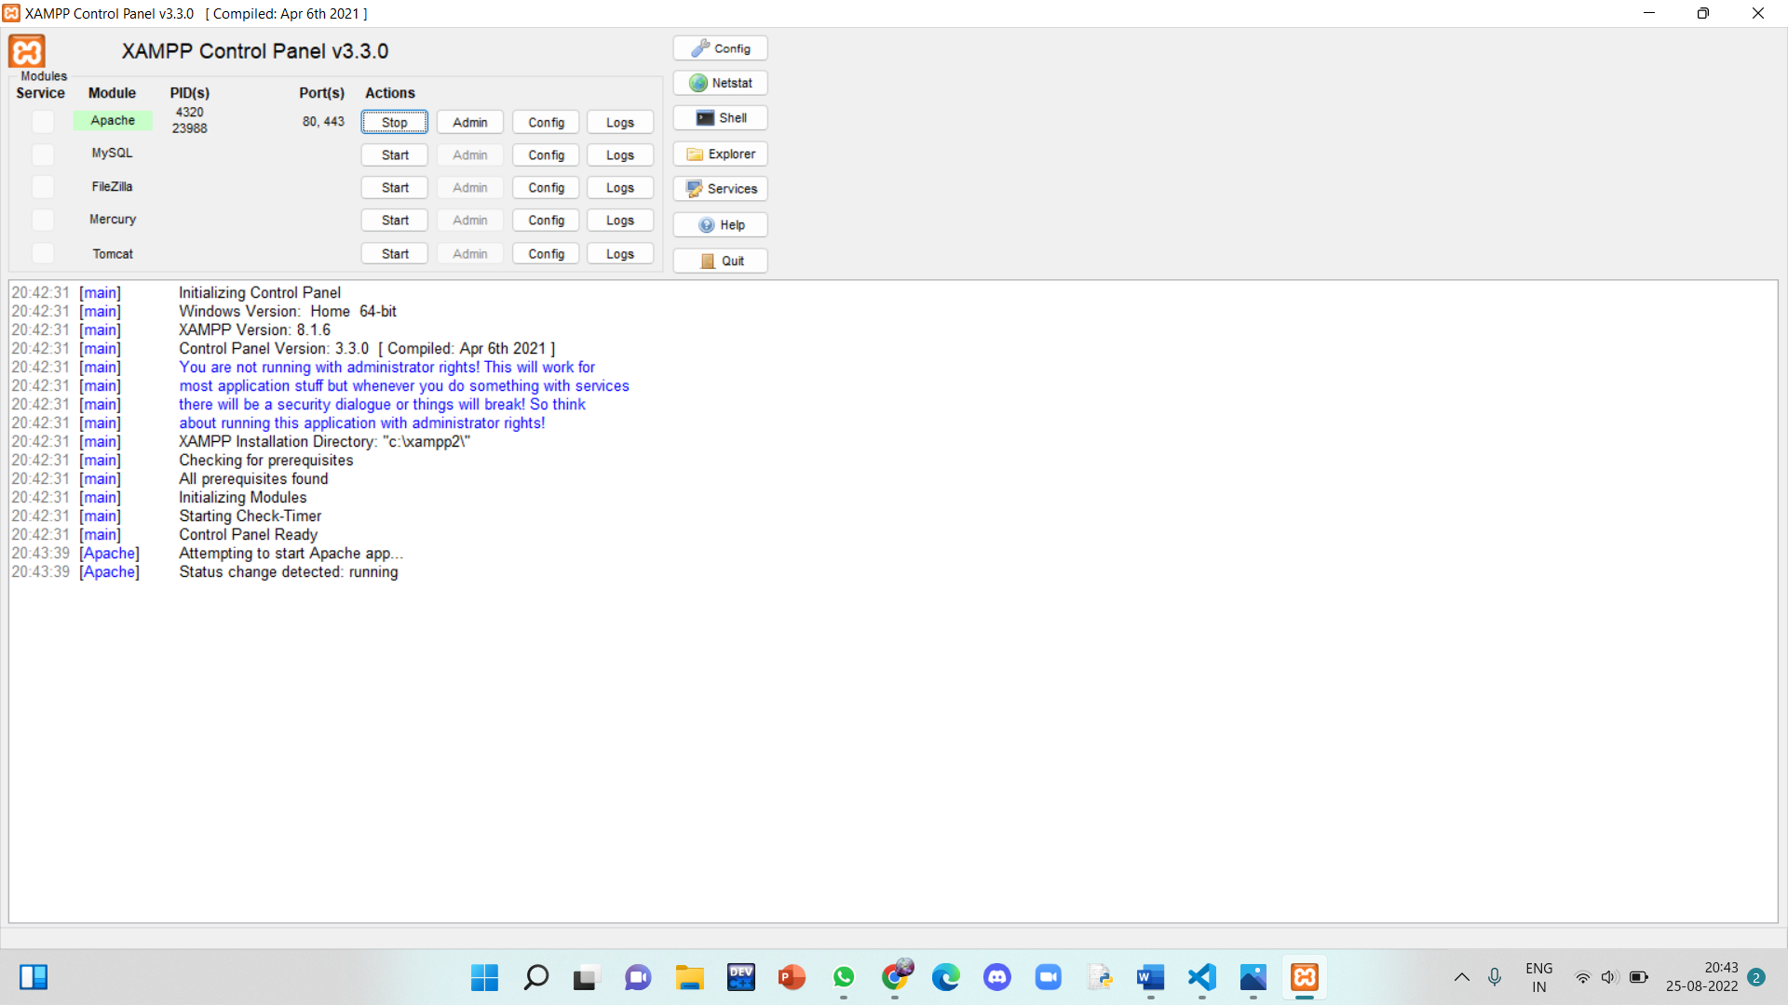

**Fig.17 “XAMPP” control panel**

And as it is running, we go to the **VSCode** and open the folder we are working on.

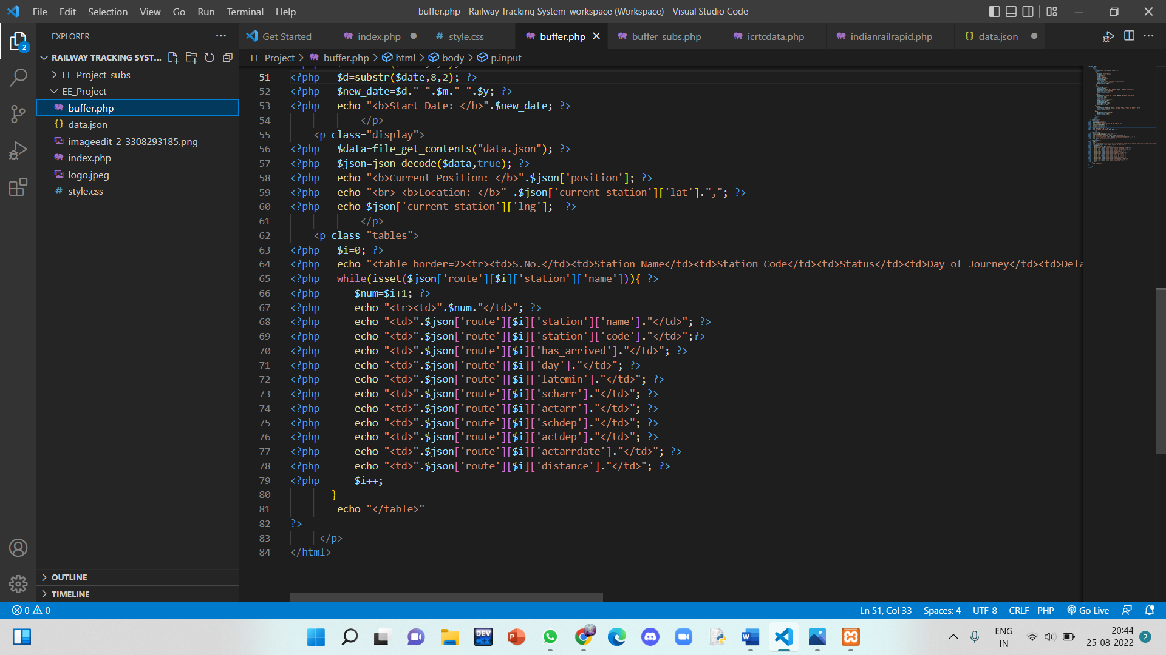

**Fig.18 Project files stored in VSCode**

There, we click on the **“Go Live”** button available at the bottom right corner to make our website go live in our browser.

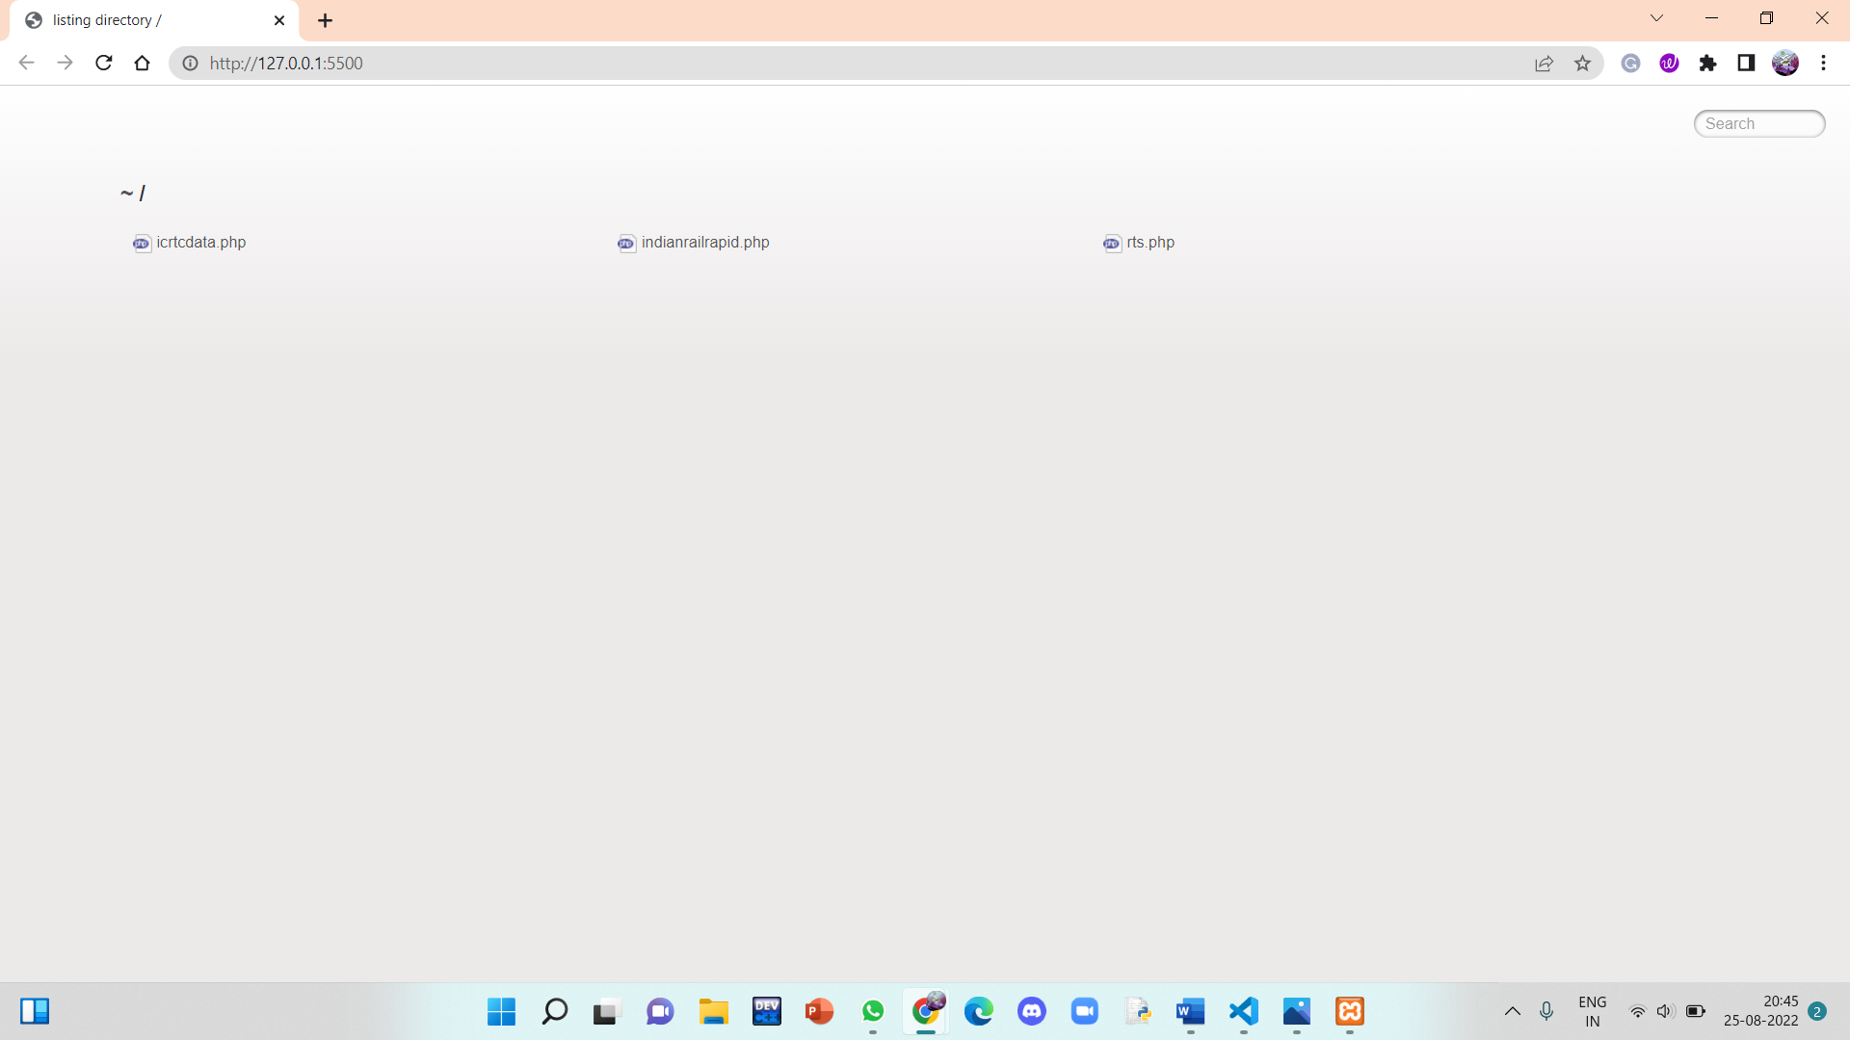

**Fig.19 The directory page opened in “Chrome”**

Now, we open another tab and enter **“localhost/<folder_name>”**, here it is **“EE_Project”**

This will give us the final results.

**RESULTS AND DISCUSSION**

**FINAL RESULTS:**

The front page of the website looks like this:

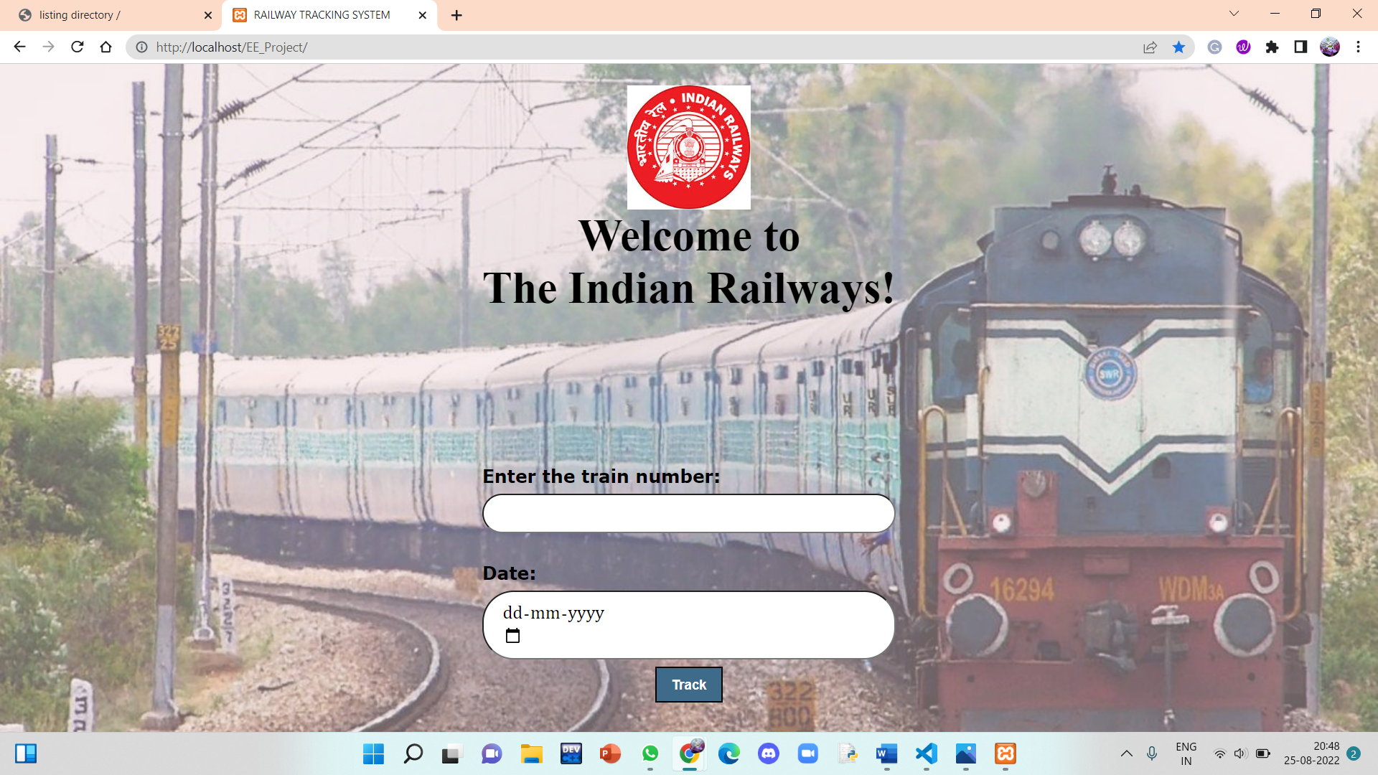

**Fig.20 Front Page of the “Railway Tracking Website”**

As soon as the user enters the train number, the date and clicks on the Track button, he/she gets redirected to another page containing the final result.

It is shown below:

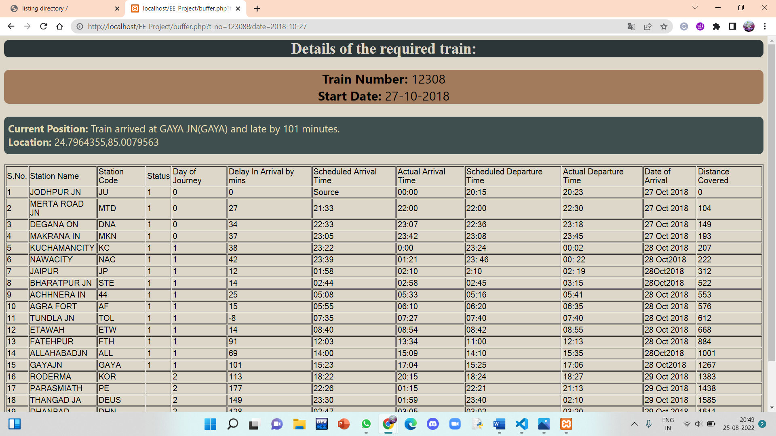

**Fig.21 The details of the train shown in the webpage after inputs are given**

**DISCUSSION:**

The data we used in our project is dummy data because we can not access original data easily that is present with “The Indian Railways Department” as it requires us to acquire a license from them. In order to get license, we should write an email to “The Indian Railway Department” as to why we need the data and how are we going to use it and seek permission. For educational and presentational purposes, in this project, real data is not used, and it is meant to show how the tracking system works.

The final output, as we aimed to achieve, has given us the essential details of the required train, a particular passenger wants to track of.

But,the data we used here is limited as it contains only one train’s details. If we can acquire more data, this project can be expanded to be more efficient and user-friendly.

Through this project, we learnt the basics of a language we are unaware of, called **“PHP” (Hyper-text Pre-Processor),** which is a server scripting language, and a powerful tool for dynamic and interactive web pages. We became familiar with the language to some extent and are now able to code basic projects in it.

We also got the hang of servers, how they are connected and used (“Apache is what we used”) and how to create and launch a website from a system.

Further, we got to know about API documentations and how data is stored, modified and used in several software and website development projects.

**SUMMARY**

The project report is based on the train tracking system which tracks a train using data obtained from an API documentation. The passenger, who wants to board a particular train and needs information of the train relating to it’s arrival and departure timings, can use our website to know the required details. When the inputs are given by the user and Track button is clicked, they are directed to a new webpage where, they can find extensive details –such as,

* The current location of the train
* Station names and codes that are in the route of the particular train’s journey
* The day of journey
* The delay in arrival by minutes
* The scheduled and actual arrival, departure timings of the train at respective stations
* The arrival status of the train at a particular station
* The distance covered by the train
* The date of arrival of the train at a particular station

**FUTURE SCOPE**

The data we used in this project for presenting the working of a “Train Tracking System” is not real. We can further develop and modify this website by enabling it to track the real location and details of the train and provide information to the passenger. This can be fulfilled by acquiring license to access original details of the train from The Indian Railway Department.

Also, we can add many other features to display more details related to the train like platform number, availability of seats, booking facility, etc..

We can advance the website by storing the details of all the trains by their unique train numbers or IDs using “Data Structures” like Hashing Tables, Linked Lists and Dictionaries, etc..

We can access the data of a particular train by it’s unique train number or ID. We can make use of several “Searching Algorithms” that are available to search for that particular ID and obtain it’s details to display to the user.

**REFERENCES**

**Video Tutorials:**

1. <https://www.youtube.com/watch?v=ORC0mKNaI9A&t=1980s>
2. <https://www.youtube.com/watch?v=dlinATkri6Q>

**Github:**

1. <https://github.com/Leoperon/Track-Train.github.io>

**Websites:**

1. <https://www.php.net/manual/en/>
2. <http://jsonviewer.stack.hu/>
3. <https://www.sitepoint.com/community/t/how-add-css-style-to-php-code/246575/2>
4. <https://developer.mozilla.org/en-US/docs/Web/CSS>